Ohio Pickling & Processing

Machine Capabilities

CAPABILITIES | PICKLE LINE | STAMCO | PAXSON
MAX GAUGE | .375” x 48.00" .312” x 60.00"  .250" x 72.00" | .126" CQ .112" HSLA  55K min. Yield | .375" CQ .312" HSLA 55K  min. Yield
MAX WIDTH | Entry: 72.00” Exit: 72.00” | Entry: 62.00" Exit: 60.00" | Entry: 74.00" Entry: 72.00"
MIN WIDTH | Entry: 24.00" | Entry: 12.00" Exit: 2.00" | Entry: 18.00" Exit: 3.00"
MIN GAUGE | .056" | .026" | .095”
MAX COIL WEIGHT | 70,000 lbs. | 60,000 lbs. | 60,000 lbs.
MAX O.D. | Entry: 78.00" Exit: 72.00" | Entry: 74.0" w/ 28.0" I.D.  Exit: 72.0" w/ 30.0" I.D. | Entry: 74.0" w/ 28.0" I.D Exit:  72.0" w/ 30.0" I.D
COIL I.D. | Min Entry: 20.00” Exit: 24.00” | Entry: 20.0" / 30.0" Exit:  20.0” / 24.0" | Entry: 24.0" / 30.0"

LEVELING CAPABILITIES:

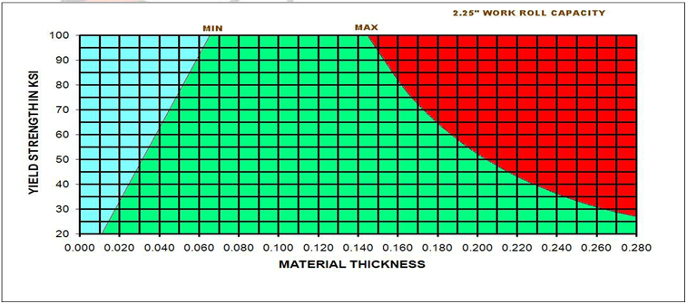

Management Team Address

Mike Balk 1149 Campbell Street
GM / Vice President Toledo, OH 43607

Kevin Burnett 419.241.9601- main
Production Manager 419.241.9635- fax

Mike Spencer x3334 sales@ohiopickling.com
Sales Manager

